**STORE MANAGEMENT FLOW**

**Main Menu.** The main menu is where the user views all the options including the store name and the users input the proper choices that existing as well as for creating an account (which is necessary).

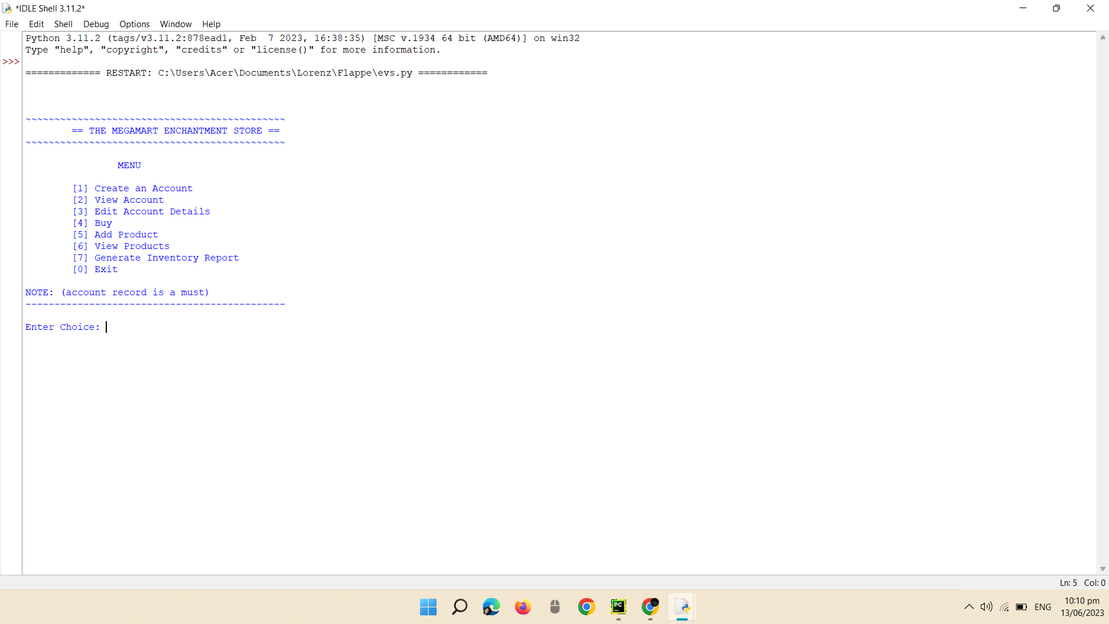

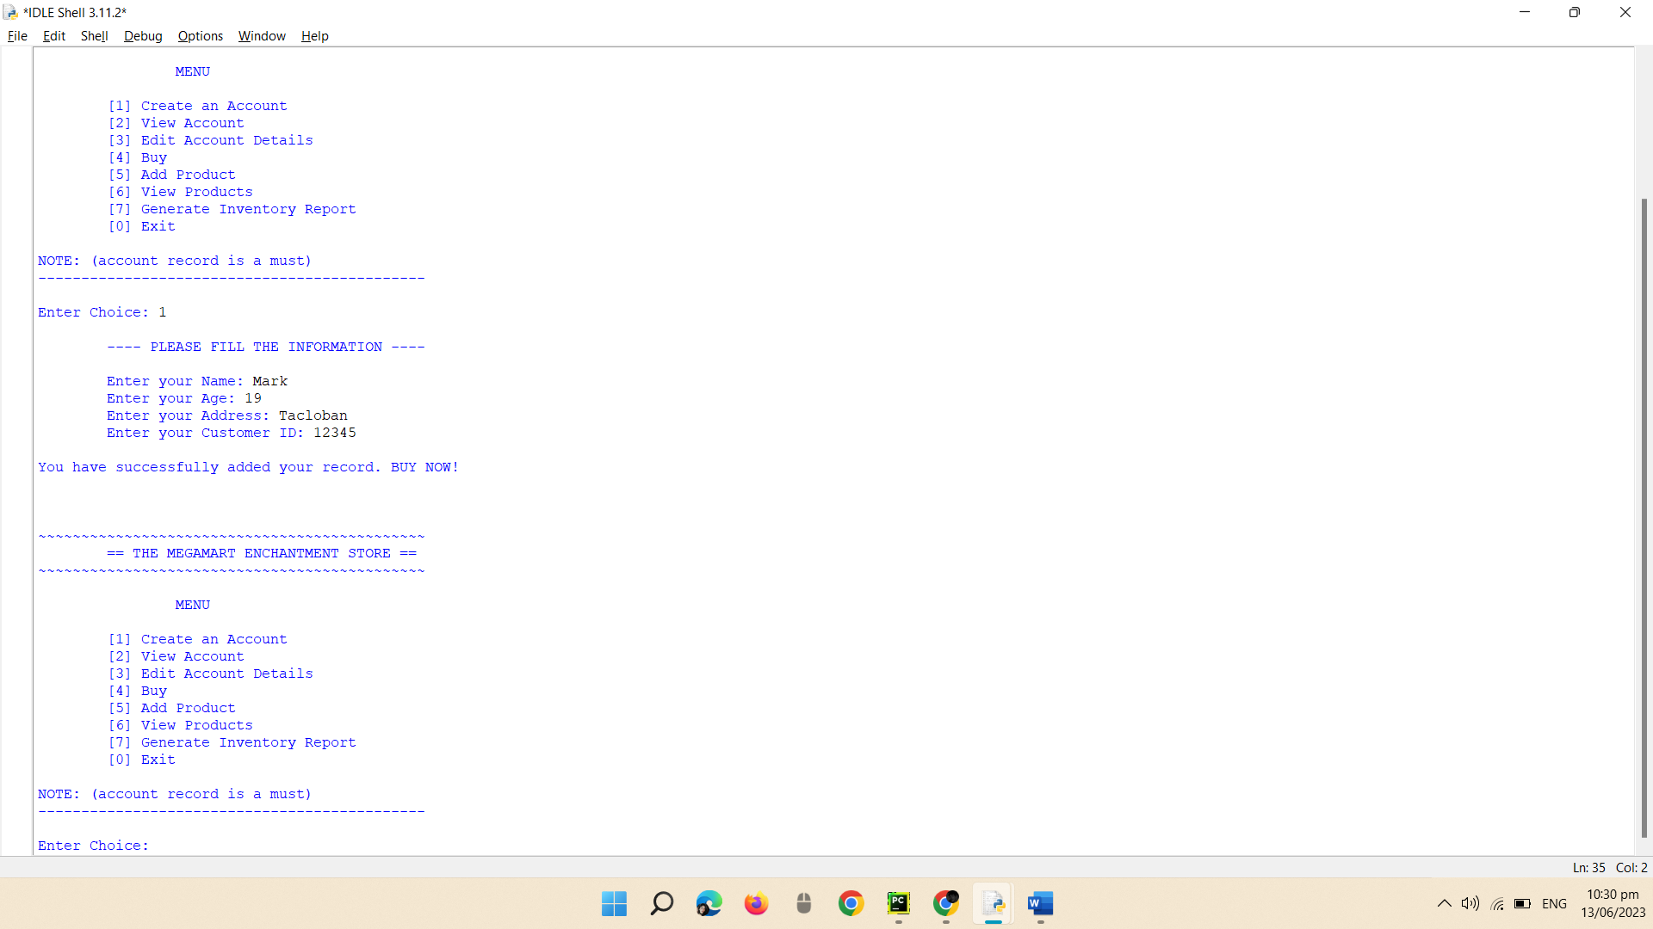**Set Up an Account.** User needs to choose Option [1] (Create an account) and filled up the info. for creating an account and a **must** for the user to Buy products in the store. When user is done, a notice will pop that your record has been added.

**Check Account.** To ensure that your account is already added, you can go to Option [2] (View Account).

**Edit Account.** This is where you revise your account if something you input is wrong. It can be edited anytime if an account is existing. Go back to Option 2 to view edited info.

(Option 3)

**Buy Phase.** This is the buy phase where user views all product and their record to enter the account record number and continue. User can choose the specific products and quantity they buy and will notice the receipt if done buying. (Option 4)

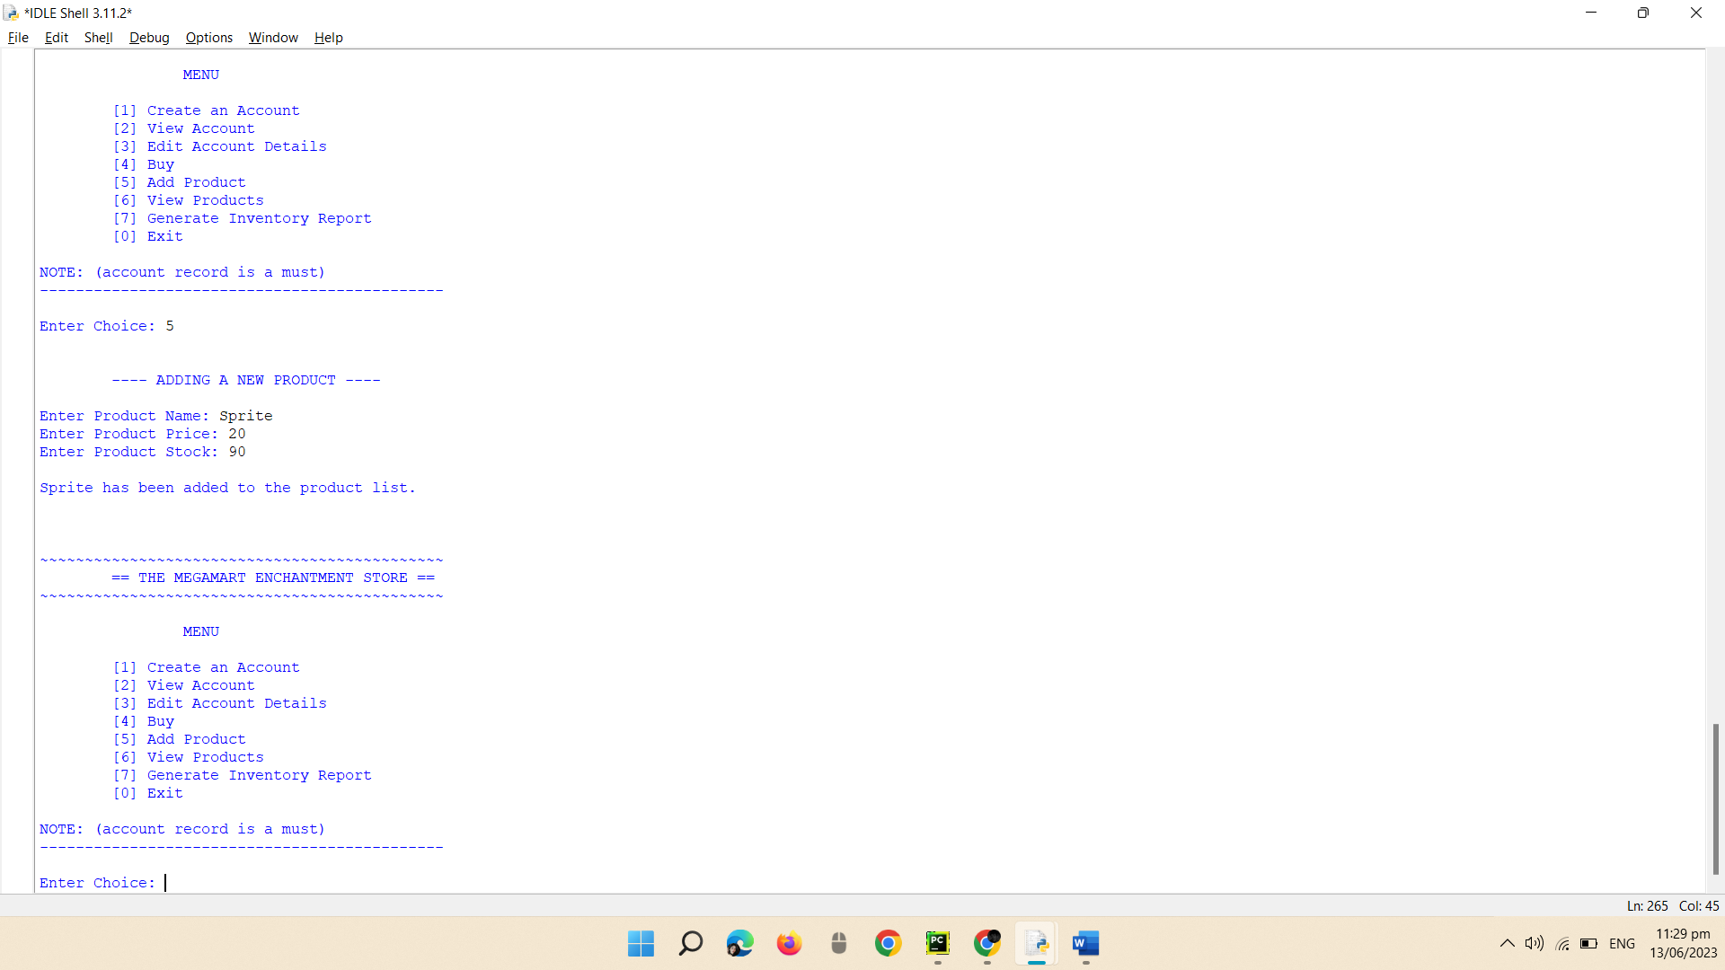**Inserting a New Product.** This where the option that adds product in the menu. (Option 5).

**Review Products.** All the product information will be displayed here along with newly added products as well. (Option 6).

**Developed Inventory Overview.** Generated inventory report is where all the Sales Details, Net Sales Income, Summary Details and all the report that has been made in the store management will be execute and printed out in this section. (Option 7).

**Exit.** If you want to exit, this is the where the program ends. (Option 0).

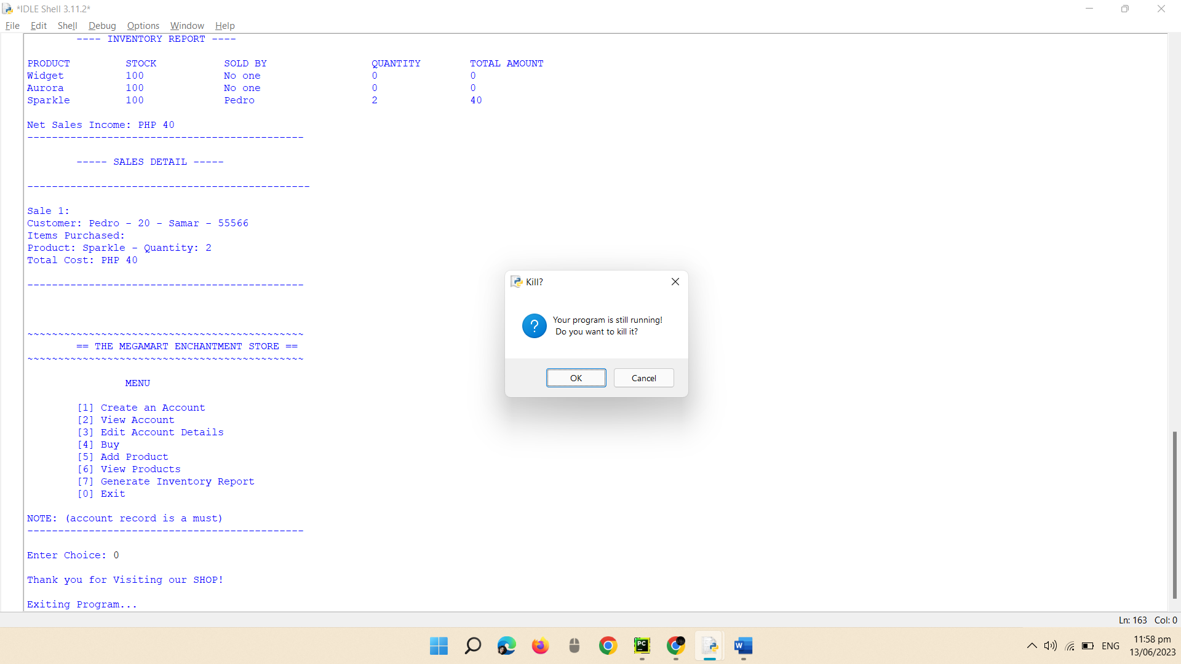



**STORE MANAGEMENT SYSTEM**

By:

Gruco, Mark Lorenz M.

Macion, Jomar Y.

Babiano, Jose Louis M.

BSIT 1A

2nd Semester SY: 2022-2023

A Technology Presented To:

**Mr. Giovanni N. de los Santos**

A Faculty of Information Technology Department

Eastern Visayas State University

Tacloban City

**Rationale**

The code for "The Megamart Store" serves as a vital tool for managing the day-to-day operations of the store. By providing functionalities such as customer record management, product inventory tracking, and sales processing, it helps streamline and automate critical aspects of running a retail business.

The ability to create customer accounts and store their information allows for personalized customer interactions and tailored services. Customers can easily view their account details, make edits if necessary, and proceed with purchases, creating a seamless and convenient shopping experience.

The integration of an inventory management system ensures efficient stock control by keeping track of product availability and automatically updating stock levels upon purchase. This functionality helps prevent stockouts and overstocking, optimizing inventory management, and ensuring that customers have access to the products they desire.

The generation of inventory reports provides valuable insights into product performance, sales trends, and customer preferences. Store administrators can analyze the data to make informed decisions about product restocking, pricing strategies, and promotional campaigns. Additionally, the inclusion of net sales income in the inventory report allows for a comprehensive assessment of the store's financial performance.

**Objectives**

* The primary objective of this code is to create an efficient and user-friendly system for managing customer accounts and store inventory.
* It allows customers to create and maintain their accounts, providing them with a personalized experience. The code also enables customers to view and edit their account details, ensuring the accuracy and relevance of their information.
* In terms of inventory management, the code allows store owners to add new products and view the existing product list, including their prices and stock levels. This facilitates effective inventory control and ensures that customers are presented with up-to-date product information.

**Significance**

By providing a user-friendly interface for managing customer accounts, it enhances the customer experience and fosters personalized interactions. Customers can easily create, view, and edit their account details, which improves data accuracy and allows for targeted marketing and communication. This not only strengthens customer relationships but also enables the store to deliver tailored services and promotions.

Furthermore, the code's inventory management features are vital for maintaining an efficient supply chain. By allowing store owners to add new products, view existing ones, and track stock levels, it ensures that the inventory is always up to date. This prevents overselling or running out of stock, optimizing customer satisfaction, and avoiding lost sales opportunities. The ability to generate an inventory report provides valuable insights into product performance, helping store owners make data-driven decisions regarding stock replenishment, pricing strategies, and identifying popular items.